Experimental Results--Expert Model

Total Time：128 min

1. Use Case Diagram

Time：5 min

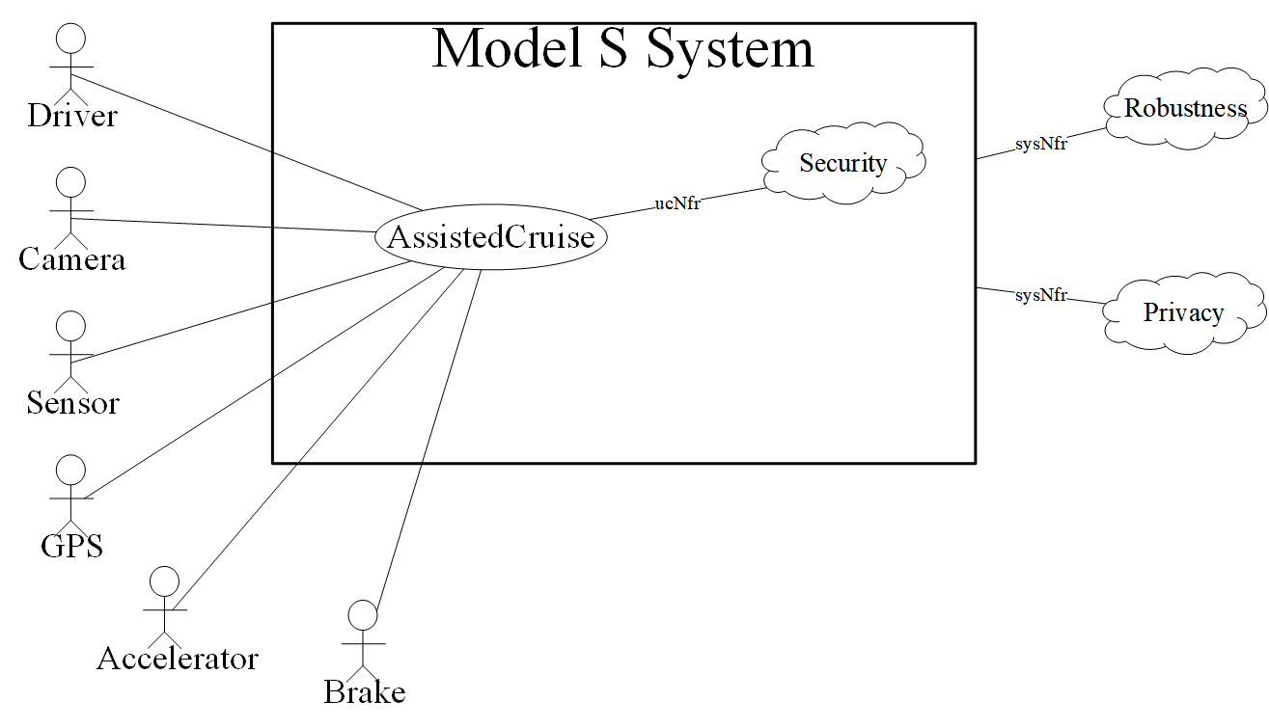

1. System Sequence Diagram

Time：55min

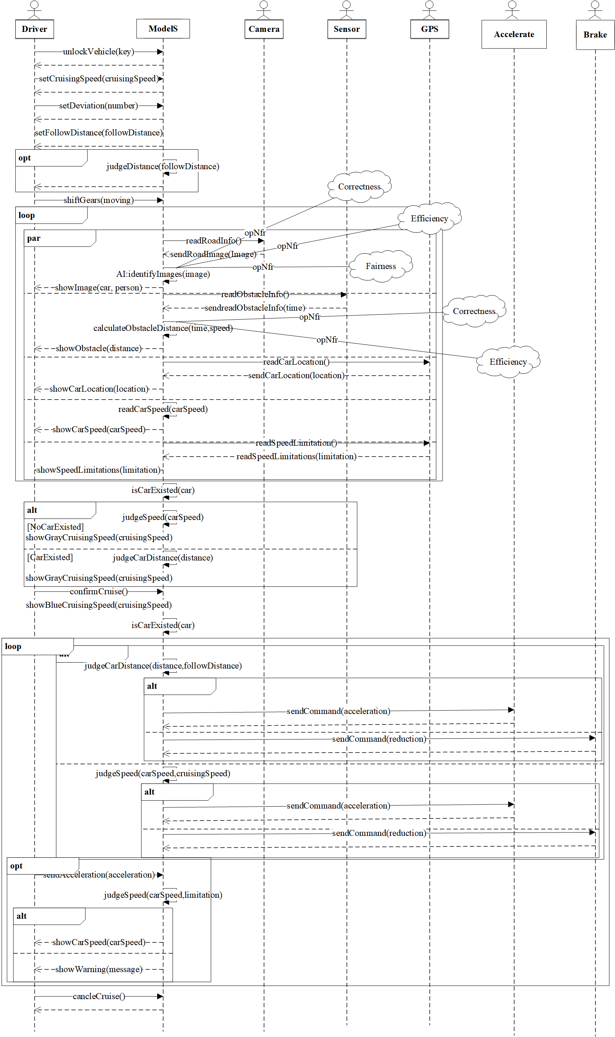

1. Conceptual Class Diagram

Time：17min

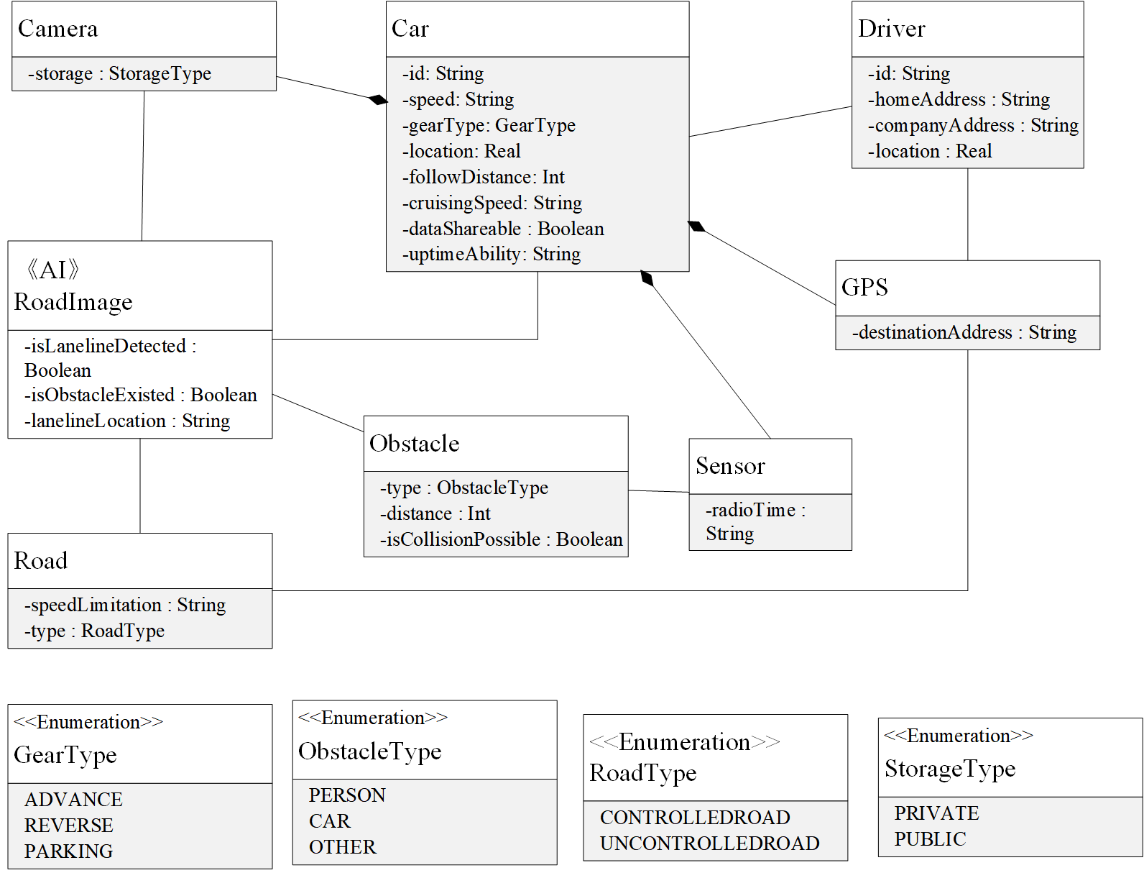

1. Context Diagram

Time：12min

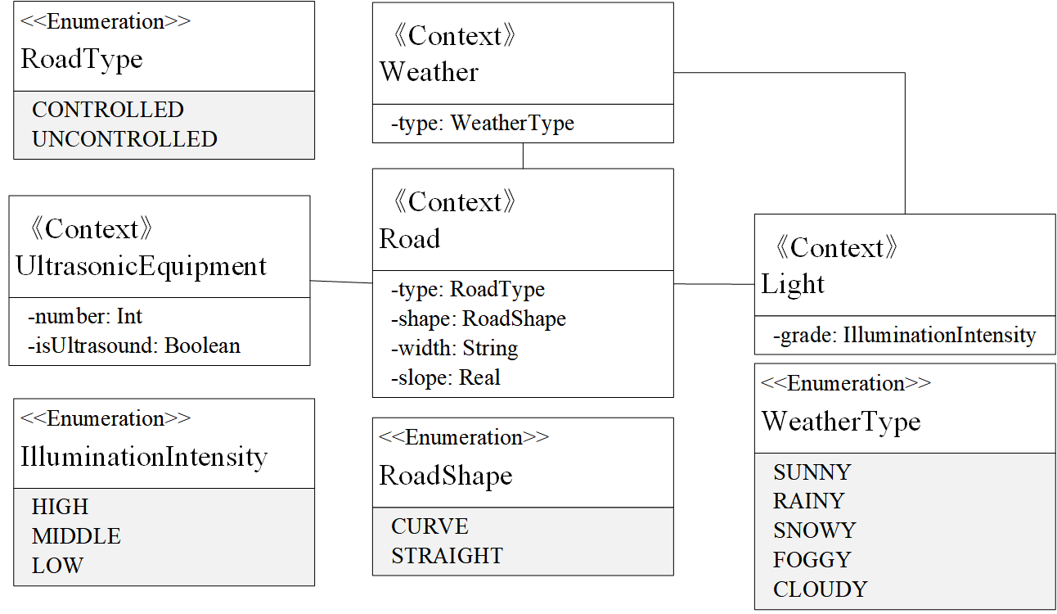

1. Machine Learning Diagram

Time：7min

